1. **Process to add New Hotel of Existing Channel Manager (No coding required):**

**1**. Update all 4 sheets of Account Manager Input Condition Master File by following the **iSell InputCondition and Pricing_Document**.

We have following list of set Channel Managers :

|  |  |
| --- | --- |
| **Sr.** | **Set Channel Managers** |
| 1 | Staah |
| 2 | AxisRooms |
| 3 | Maximojo |
| 4 | Djubo |
| 5 | eZee |
| 6 | SiteMinder |
| 7 | AsiaTech |
| 8 | BookingCentre |
| 9 | ResAvenue |
| 10 | RezNext |
| 11 | BookingHotel |
| 12 | TravelClick |
|  |  |

If it is **eZee** channel manager, you need to update the date format of Checkin Checkout columns of the hotel OTA data in **ezeedate_format.xlsx** master file. As for **eZee** the hotel wise date format is different.

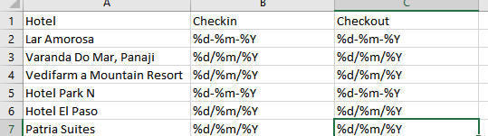

**2. Put the data required to Run the iSell in InputData folder.**

**Ex**. Demand Calander, CM_Availability, HNF, OTA_Data, OutPut_CSV, Price_Calendar, Pricing_Grid, Rateshop, RS_Data.

Set **dummy** **Last Report iSell** CSV by setting OTA_Sold column to Zero.

**3. Run iSell Tool.**

1. **Process to add New Channel Manager (coding required):**
2. Update **cm_master.xlsx** master file**:**

Get **Transactional** level data / **OTA** data of new channel manager and update the required column names which corresponds to below list in **cm_master.xlsx** file. Keep stdname at the rightmost and don’t make any change to stdname column.

|  |  |
| --- | --- |
| **New_ChManager** | **stdname** |
| Name of column which provides channel /OTA information | Channel |
| Name of column which provides booking status information | Status |
| Name of column which provides checkin /arrival date | CheckIn |
| Name of column which provides checkout/departure date | CheckOut |
| Name of column which provides no of rooms information | No_of_Rooms |
| Name of column which provides Amount information(Total/Net) | Total_Amount |

Note: Most of the channel managers OTA data don’t have information of number of rooms.

In that case set **“Rooms”** as column name and need to set this column to **value 1** in **ProcessFlow** module, will be explained this further.

1. Update the new channel manager name in **DropColumns.xlsx.** This master file is **to delete not required columns** from iSell dataframe. If not single column to drop, keep it blank.
2. **DateFormats.xlsx:**

Set date format of .csv files carefully by opening them in notepad ++.

|  |  |
| --- | --- |
| **CM** | **New_Chmanager** |
| CheckIn | date format of checkin date of OTA data |
| CheckOut | date format of checkout date of OTA data |
| extension | file extension |

1. **Statuscodes.xlsx:**

Get the status values by extracting at least a year information and update new unique status values to statuscodes.xlsx master file. Check if those status values are already updated in file or not. If they already present, no need to update. We update **Cancelled and NoShow** status values to **0.**

1. **Format2_iSells.xlsx:**

Update the standard name of hotel to prepare format2 isell, provided need to update name of the hotel twice in iSell input condition as (**hotelname** and **hotelname_OTA**).

**ProcessFlow Change(coding):**

1. **Add New channel Manager name in condition:**

In main for loop of ProcessFlow, there is if-elif conditions for each channel managers.

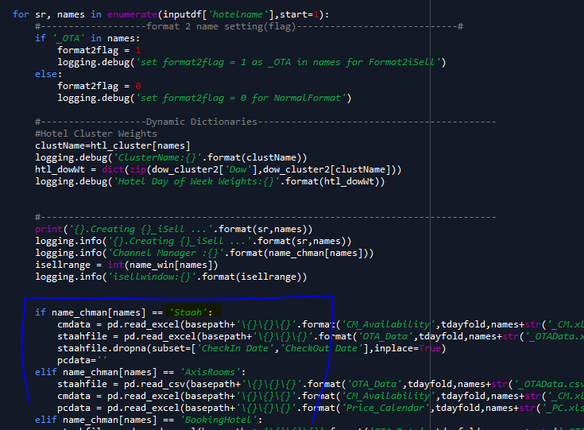

You need to create one **extra elif condition** for New Channel Manager and read the required iSell data in standard variables . Ex.

staahfile = it is variable which reads OTA data file.

cmdata= it reads CM Availability file

pcdata= it reads Price Calendar, which provides rates in separate file.

If we are not getting the data for any file, keep that variable blank by assigning ‘ ’.

i.e pcdata = ‘ ‘

**Creating “Rooms” column in OTA data:**

This is for those channel managers with no of rooms column missing.

Create one column “**Rooms**” in staahfile variable and assign value 1 to it.

You can follow below screenshot. For **eZee** channel manager we added “Rooms” column and assigned value 1 to it, as eZee OTA data is not providing no of rooms information.

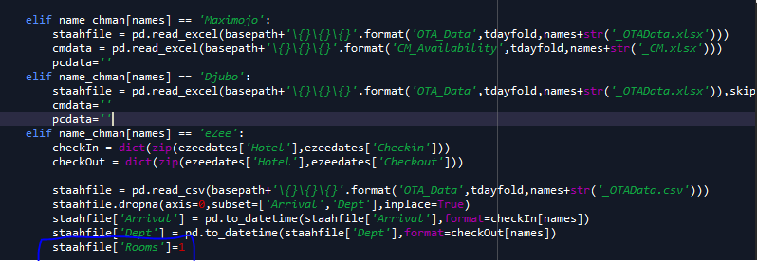

You can do OTA data or CM data or PC data **cleaning** if required in this **elif** condition itself.

1. **Add CM_Availability function for New Channel Manager in CMAs:**

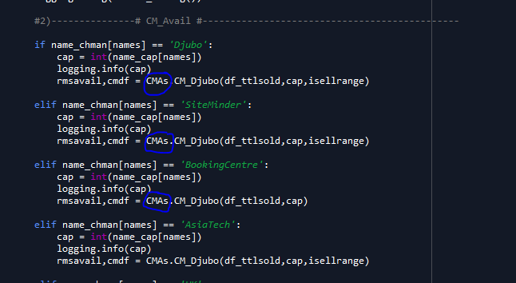

As per the above screenshot, there is different function for CM_Availability module to each channel manager in **CMAs** module. You need to add separate function in CMAs module for new channel manager. For that add one extra **elif condtion** with new channel manager name in ProcessFlow module to call function in CMAs, as shown above.

**Note**: If we don’t get the rates data for RateOnCM (ex. we don’t get CM data for Djubo) then no need to create extra function, you can directly use **CM_Djubo** function for new channel manager by passing parameters (df_ttlsold,cap,isellrange). As in above screenshot all channel managers use same function CM_Djubo as they don’t have CM_Availability files or Rates information.

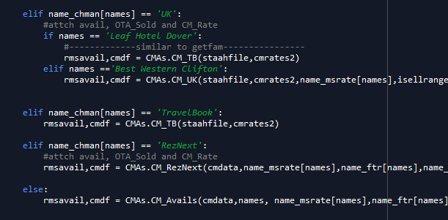

**Create Function in CMAs:**

You need to create extra function for those channel managers which provides availability data (rooms available to sell online) and rates data (PC data or RateOnCM). As above screenshot have different individual functions for getting availability (**rmsavail**, **cmdf**) and rates information.

1. First add new channel manager condition in **CM_Avails** function.

It returns dfa (availability frame with flow through) and dfb (rate on CM frame) to ProcessFlow.

1. Create newChannel manager function in CMAs module, and get availability, flow through availability and rate on CM. This module should be called in **CM_Avails** function.

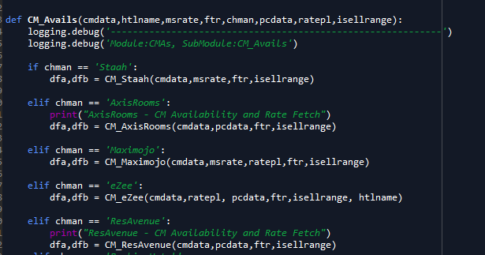

1. Return two dataframes (availability and rateonCM) from newly created function to CM_Avails in to **dfa** and **dfb**. It will be returned to ProcessFlow.
2. Only this much of coding change needed. iSell will be created in masters folder and OutPut_CSV folder.